

**Design Studio #4 - Weekly Progress Report #12**

DS Instructor: Gülbin DURAL

Partners:

* Fatih ÇALIŞ
* Fatih ÇAM
* Recep GÜNAY
* Huzeyfe HİNTOĞLU
* Sarah ILYAS

In this week, we focused on building the shooting mechanism as it is now the most crucial part of the system as we need to finalize our decision on that until 8 March, CDR due. As we mentioned earlier in our presentation and PDR, we are planning to construct the shooting mechanism by making use of mechanical spring force. We built a shooting mechanism with the spiral 3D printed material. It is a little bit heavy for our operation and step motor was not able to handle it easily. Hence, the new material is designed and will be printed on this week.

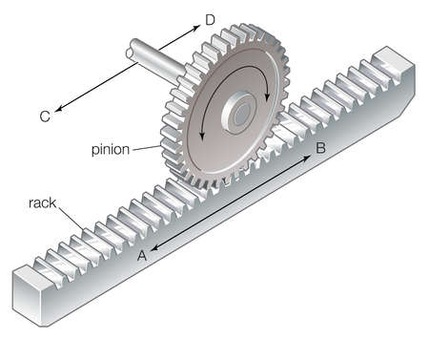

*Figure 1: Rack and Pinion Mechanism*

We are planning to use a spiral shaped shooting mechanism. However, an alternative mechanical solution is using ‘Rack and Pinion Method’. A rack and pinion is a type of linear actuator that comprises a pair of gears which convert rotational motion into linear motion. A circular gear called "the pinion" engages teeth on a linear "gear" bar called "the rack"; rotational motion applied to the pinion causes the rack to move relative to the pinion, thereby translating the rotational motion of the pinion into linear motion. The system is illustrated in Figure 1. (Huzeyfe)

To test the shooting operation, I have built a prototype for the shooting mechanism, which is shown in Figure 2.

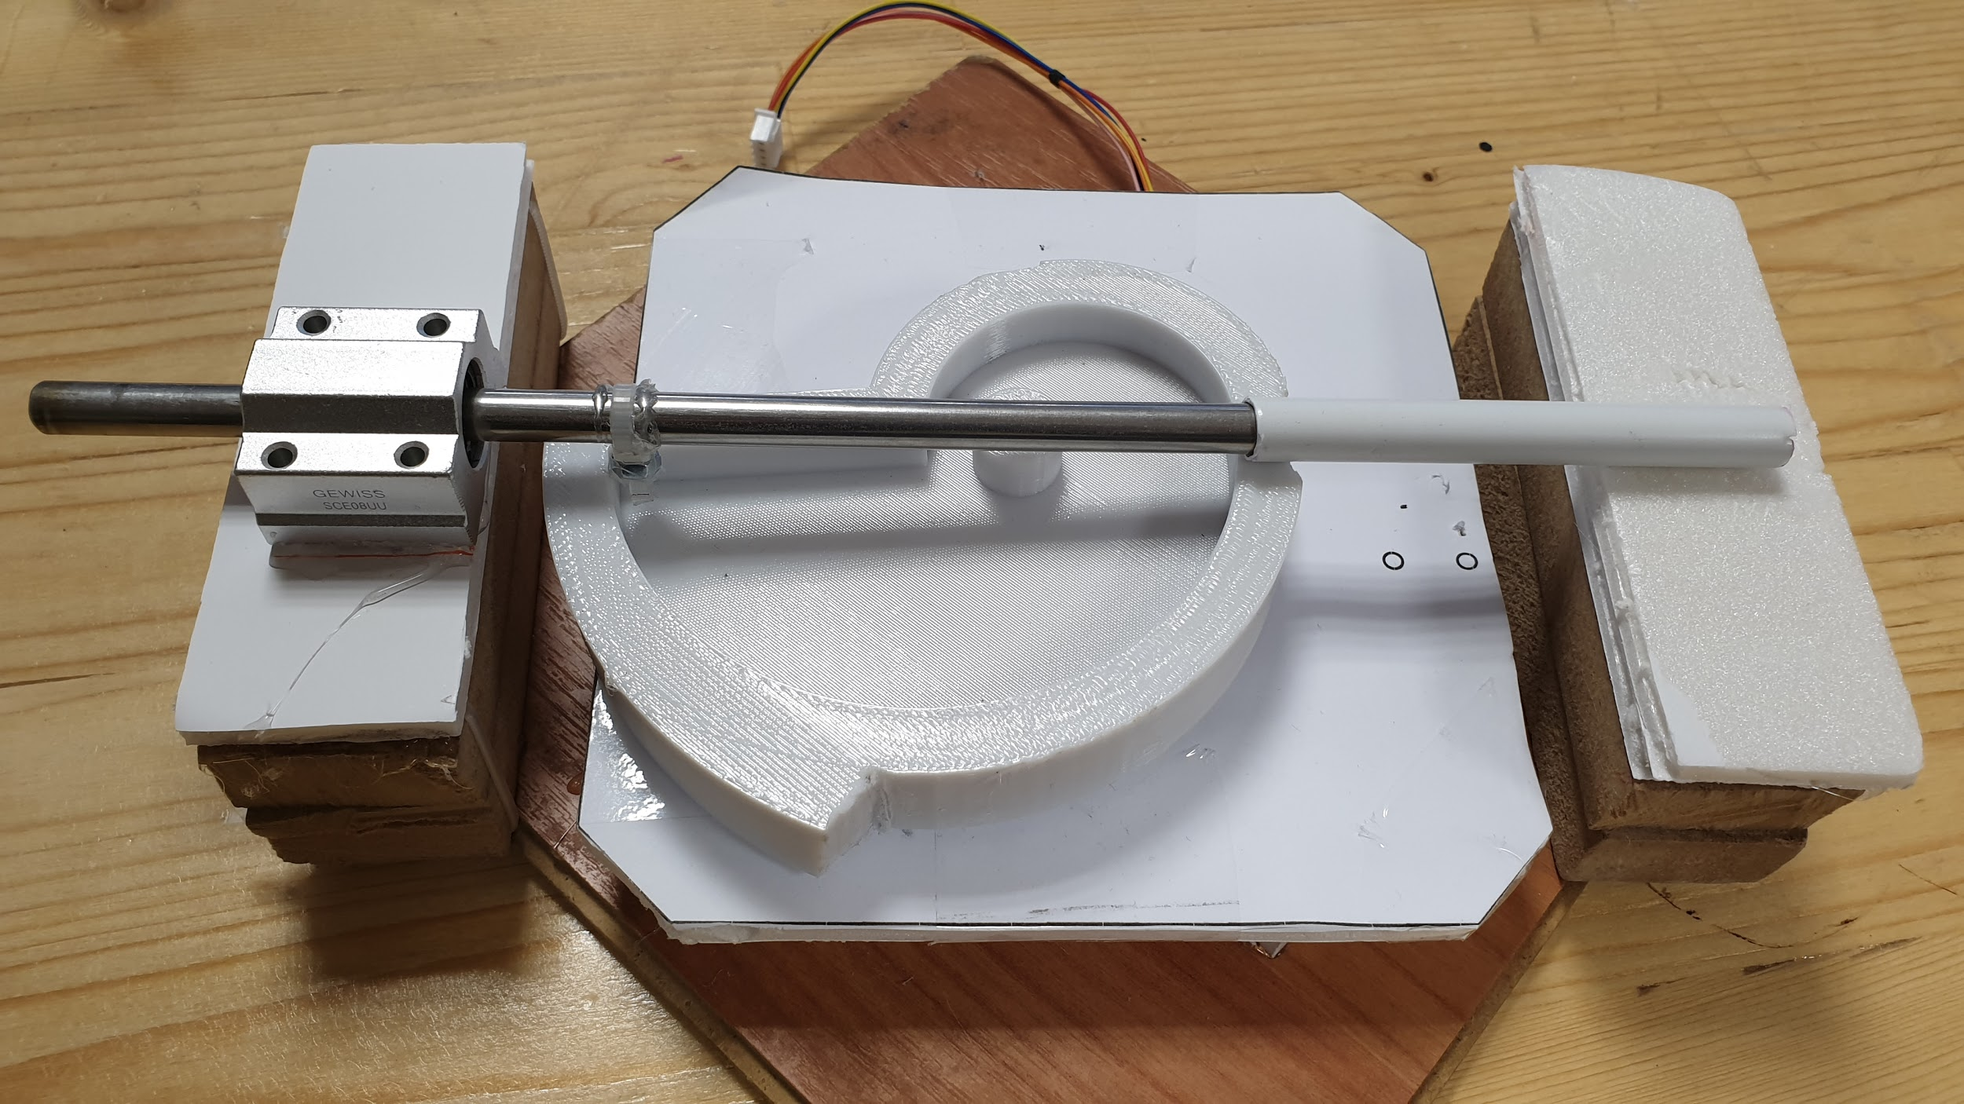

*Figure 2: The test prototype of the spiral-shaped shooting mechanism*

After the tests that I conducted, the sliding rod appeared to rotate around its sliding axis, which is not desired. Another problem about this setup is that the center of mass is not coincident with the rotation axis of the step motor. As a result, the spiral rotates with an angle, which increases the friction. To get rid of these two problems, I decided to update the spiral shape to one shown in Figure 3.

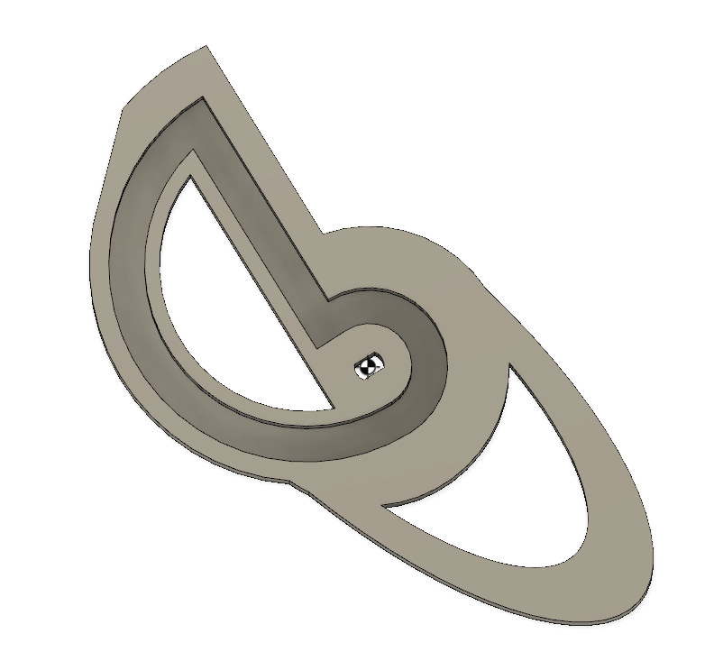

*Figure3: The new spiral component whose cg is coaxial with the rotation axis*

Analysis of the viability of employing particular assembly techniques with Plexiglass

· **Adhesives**

After analysis of the relevant literature, I found that Methylene dichloride is the most effective solvent for bonding Plexiglas acrylics. This form of attachment is preferable when the materials involved are fragile, brittle or irregular. While this technique may be of utility for a few parts, it might be inconsequential for full assembly.

· **Welding**

Common welding techniques include; ultrasonic, vibration, and hot plate techniques.

Welding methods are best suited for applications where leak proof, permanent, attractive, or contamination free high strength bonds are required. However, this form of assembly can be quite costly and therefore does not hold high practical significance for us.

· **Annealing**

The primary benefits of annealing Plexiglas parts are improved resistance to external stresses (mechanical or chemical) and greater dimensional stability at elevated service temperatures. Annealing is the process of heating a molded part for a period of time at a temperature near, but below, it’s softening point. After heating the part, slow, uniform cooling will cause stress relaxation without distortion of shape. The ultimate goal of annealing is to redistribute and reduce the stresses.

· **Mechanical Attachments**

This technique is the most viable and feasible given our circumscribed budget. This assembly mechanism also gives us a lot of leeway for design and aesthetics. The following figures depict the various types of mechanical attachments that can be employed.

Screw fastening



*Figure 4: An example of screw fastening*

Riveting

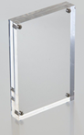

*Figure 5: Figure depicting riveting*

Snap-fits

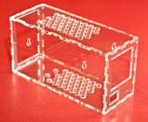

*Figure 6: An example of snap fits*

(Sarah Ilyas)